ATHENA - AUTONOMOUS TRIAGE AND HEALTHCARE ELECTRONIC NEURAL ASSISTANT
Scope and Limitations
Department of Computer Science and Engineering, TKR College of Engineering & Technology
Batch A7 (CSE-A) · Academic year [ACADEMIC YEAR]
Table 1: Project team
S.No. | Student name | Roll number
1 | Badaveni Srinath | 23K91A0523
2 | Basani Avinash | 23K91A0532
3 | Degala Praneeth | 23K91A0561
4 | Bontha Saisree | 23K91A0545

Project guide: K. Shalini
Chapter and section numbers quoted in the text (for example Chapter 8 or Section 6.2) refer to the full project report, 17.Final Document. Figures and tables in this document are numbered from 1.

1. SCOPE

1.1 What is in scope
• Reading a PDF or PNG/JPG report of up to 15 MB: symptoms, findings, history and six laboratory values, each kept with the page it came from.
• Entering eight vitals (age, heart rate, systolic and diastolic pressure, SpO2, temperature, respiratory rate, arrival mode) and fusing them with the report flags.
• Assigning a priority from 1 (Critical) to 5 (Non-urgent), a risk level (High, Moderate, Low), a calibrated confidence and a per-patient SHAP explanation.
• Accepting or changing the priority with a reason, a live queue ordered by priority then arrival, a performance page and a triage-summary PDF.
• Training and evaluating the model offline on a seeded synthetic data set, and measuring accuracy, calibration, robustness, reader quality and processing time on one machine.

1.2 What is out of scope
Table 2: Items deliberately not covered
Item | Why it is out | Where it appears
Training or testing on real patient records | No real triage data set was obtained; the Kaggle download script exists but was never run | Future scope
A medical language model (BioBERT) for extraction | A rule-based lexicon with negation was used; no model download or GPU | Future scope
RAG, multi-agent orchestration, LIME | Named in the batch abstract; not built | Future scope
Risk models for six diseases (diabetes, heart, CKD, breast cancer, liver, sepsis) | Only the five-level triage target was built | Future scope
MongoDB, Node.js and Flask services | SQLite, FastAPI and a React single-page app were used instead | Chapter 5
Hospital integration (HL7, FHIR, EHR feeds, bedside monitors) | Vitals are typed by the user | Future scope
Clinical validation, regulatory review, user study | Decision support for a demonstration; no clinician took part | Limitations
Production security (TLS, rate limiting, secret management, audit) | Local demonstration service | Limitations
Adversarial inputs and large-scale load testing | Not attempted | Limitations

2. ASSUMPTIONS
The results and the design rest on the following assumptions.
• The synthetic generator's seven archetypes and its severity rule are a stand-in for clinical triage. The recorded priority in the data is that rule plus noise, not a clinician's decision.
• Eight vitals and 28 report flags are enough to describe a patient at the door; real triage also uses the chief complaint wording, pain scores, mental status and the nurse's overall impression.
• A report finding that is not mentioned is absent (flag 0). This is the base paper's rule and ATHENA's, and it is wrong whenever the report is silent about something present.
• Clinical terms in a report appear in the lexicon's forms (including common abbreviations and OCR run-ons) and negation precedes the term within 45 characters in the same clause.
• Reference ranges for the six laboratory values are fixed adult values and do not depend on age, sex or units other than those the lexicon expects.
• The service is run locally by a trusted operator; there is no hostile client, and the demo accounts are the only users.
• A clinician reviews every priority before it is acted on; the system never replaces that review.

3. LIMITATIONS

Data and model limitations
• All model results are on synthetic data. The 69.4% exact accuracy measures how well XGBoost recovers a known additive rule from 3,840 simulated cases; it says nothing about agreement with clinicians. A noise ceiling of 86.25% caps exact accuracy for any model, and the shipped split (seed 7307) is a below-average split: five other seeds give 71.6% on average (sd 0.9 points).
• The sickest patients are under-triaged most often. Recall for priority 1 is 43.9% and for priority 2 54.0%; for the combined high-risk group (P1 and P2) recall is 66.2% at argmax with precision 90.6%. Overall 21.3% of cases get a less urgent priority than recorded and 9.2% a more urgent one; 2 of 66 priority-1 cases were placed at priority 3 or lower urgency, none at 4 or 5.
• A linear model beats the shipped model on this data. Logistic regression scores 72.42% against 68.25% for uncalibrated XGBoost on the same split, because the labels come from an additive score. XGBoost was kept for SHAP tree explanations and calibration, not because it won.
• Calibration improves only modestly. Expected calibration error falls from 0.047 to 0.041; the 0.8 to 0.9 confidence bin is over-confident (66% observed accuracy), so a confidence figure must not be read as a probability of being right.
• Missing report findings are costly. If 10% of positive report flags are dropped, accuracy falls to 66.2%; at 20% to 62.1%; with no report at all to 33.9% (within one level 70.4%).

Report-reader limitations
• Perfect scores on the samples are not a result. The 12 generated sample reports are read exactly (12 of 12, precision and recall 100%) because they were written with the lexicon in view.
• On 40 hand-written fragments the reader reaches precision 95.2% and recall 84.3%, with 27 of 40 fragments read exactly. Paraphrases outside the lexicon ("cannot catch his breath", "crushing pain in the centre of the chest") reach only 14.3% recall; the fragments were written by the developers, so this is not independent clinical text.
• Negation is the weakest category (precision 50% on the stress set): "Afebrile" is read as fever, "Chest pain: absent" still flags chest pain, "denies syncope but reports chest tightness" drops the chest pain because the 45-character window ignores "but" (one expected-failure test records this), and "haematemesis" also triggers vomiting.
• OCR quality is untested on real scans. Only four generated PNG scans were read; handwriting, stamps, tables, multi-column layouts and low-resolution phone photographs were not tried. Split words from OCR ("vomit ing") are missed.
• The lexicon is English-only and fixed: 22 flags and six laboratory tests, with adult reference ranges.

System and security limitations
• Demo-grade security. The JWT secret defaults to dev-secret-change-me when JWT_SECRET is not set (PyJWT warns that the key is 22 bytes), there is no HTTPS, no rate limiting, CORS is fixed to localhost origins, and the two demo passwords are seeded. Passwords are bcrypt-hashed and every patient route needs a token.
• No audit beyond overrides. Who viewed or downloaded what is not logged.
• SQLite and one process. No concurrency, no migrations, no backup; the performance page's live averages come from this one database.
• Vitals are typed. There is no feed from a monitor, and the validation ranges (for example SpO2 50 to 100) are permissive.
• Latency is measured on one CPU-only machine: scanned images take about 2.2 s to read, PDFs about 9 ms.

Evaluation limitations
• One synthetic data set from one generator; no real hold-out; no significance tests; no confidence intervals beyond the five-seed and five-fold spread.
• The comparison with the base paper is indicative only: it diagnoses ICD-10 classes on real records, ATHENA assigns five priorities on synthetic ones.
• No clinician took part: no usability study, no inter-rater comparison with nurses, no prospective trial.
Two figures show the limitations that matter most for reading the numbers. The first shows how accuracy falls when the report reader misses findings: with no report at all the model is close to the vitals-only result. The second shows how well the report reader does on 40 hand-written fragments, by category: negation and paraphrases are its weak points.
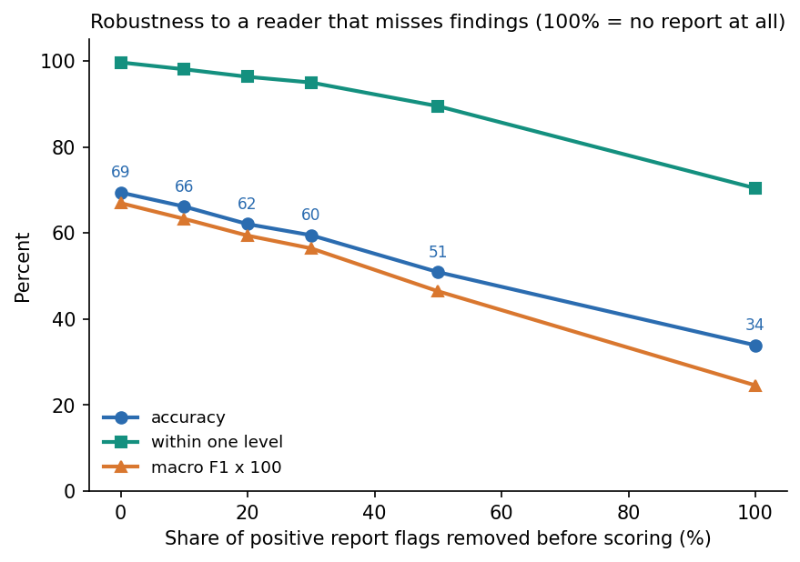
Figure 1: Accuracy of the shipped model on the synthetic hold-out when a share of positive report flags is dropped at inference.
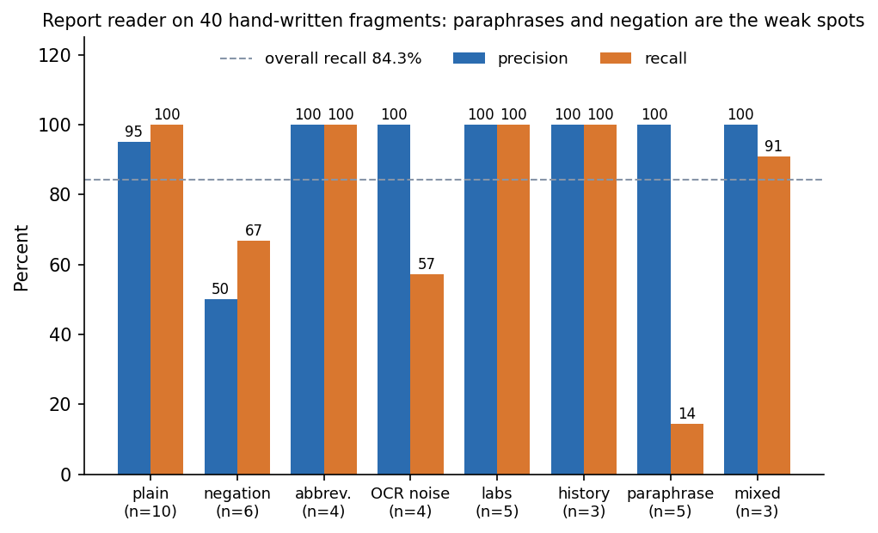
Figure 2: Precision and recall of the rule-based report reader on 40 hand-written fragments, by category.

4. WHAT WAS NOT MEASURED
The following were not measured and are therefore stated as gaps, not as results.
• Agreement with clinician-assigned priority on real patients (objective 6 is met only against the synthetic recorded priority).
• Reading accuracy on real scanned reports of varied quality, languages and layouts, or against a second reader.
• Performance on any real triage data set, including the Kaggle set the download script targets (the script was never run and its licence is not stated).
• Usability, workload and time saved for nurses, and the rate at which clinicians change the model's priority (the performance page can show it, but no clinician used the system).
• Behaviour under concurrent users, large queues, long uptime and database growth.
• Memory and energy use of the OCR engine and the model.
• Robustness to adversarial or deliberately misleading reports, and security testing beyond the checks in Chapter 7.
• A fresh-machine run of setup.bat and of the Kaggle download script; neither was tested in this documentation run.
• Statistical significance of differences between the eight models.

